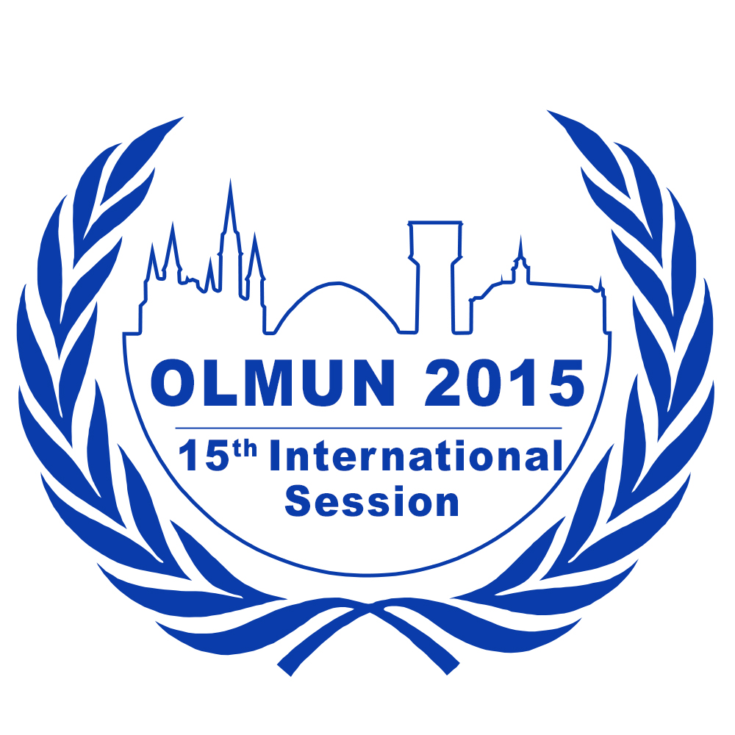
Chair Application Form

June 23rd – June 26th, 2015
www.olmun.org

Emma Beelen
President of the General Assembly
Eichenallee 1
26203 Wardenburg
Germany
0049 (0)152 0544 4091
president@olmun.org

To apply for a chair position at OLMUN 2015, please complete this form and send it to president@olmun.org by the following deadlines:
- 30th of November (11:59 pm) if you are a member of the OLMUN e.V. (internal application)
- 14th of December (11:59 pm) if you are not a member of OLMUN e.V. (external applicant)
If you are an external applicant please ask a referee (your MUN-Director or any other eligible referee) to send a Letter of Recommendation to president@olmun.org by the 14th of December.
Furthermore, we would be thrilled if you could, while sending your Application Form, inform us when you have time for an interview (face-to-face for internal applicants; via Skype for external applicants). The interviews should take place within a week from either deadline and will take around 30-60 minutes each.

Name: | School/University:
Gender: | Field of study:
Date of Birth: | Phone:
Nationality: | Mobile:
Graduation: | Home address:
Grade/Semester: | E-mail:

Last English mark/course:

Do you have any English Language Certificates or other considerable qualifications concerning your English language abilities (such as a stay abroad)?

Please state your MUN experience.

Date (Month/Year) | Conference | Position/Committee

Which of the eight committees available at OLMUN 2015 (see below) would you like to chair?

Please give reasons for your choice.

The following committees are available at OLMUN 2015:
Third Committee of the General Assembly (GA 3rd)
Fourth Committee of the General Assembly (GA 4th)
Special Conference (SpC)
Economic and Social Council (ECOSOC)
Human Rights Council (HRC)
UN Environment Programme Governing Council (UNEP)
Security Council (SC)
New Committee (XXXX)

(For detailed information on the committees visit olmun.org)

In order to assess your suitability for a chair position at OLMUN 2015, we would like you to answer a few questions. There is neither a minimum nor a maximum length for these answers.

1. What do you think qualifies you for an OLMUN chair position?

2. What is your personal motivation for applying for a chair position and what do you wish to accomplish for yourself through your participation in the OLMUN chair team?

3. How do you think a committee should be chaired?

In case of any concerns and questions, please do not hesitate to contact us via e-mail (president@olmun.org).

